CST 2309 Lab 1 – Maximo Antigua

Add a screenshot **of the source code** for the cityTechBookstore.html file.

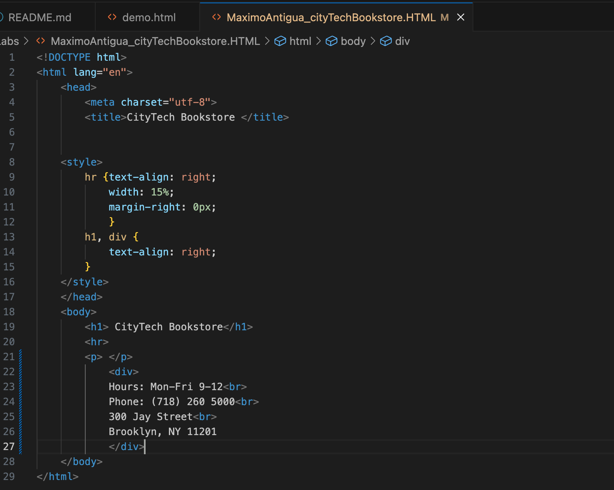

Add a screenshot of the cityTechBookstore.html file **displayed in a browser. Include the address bar**

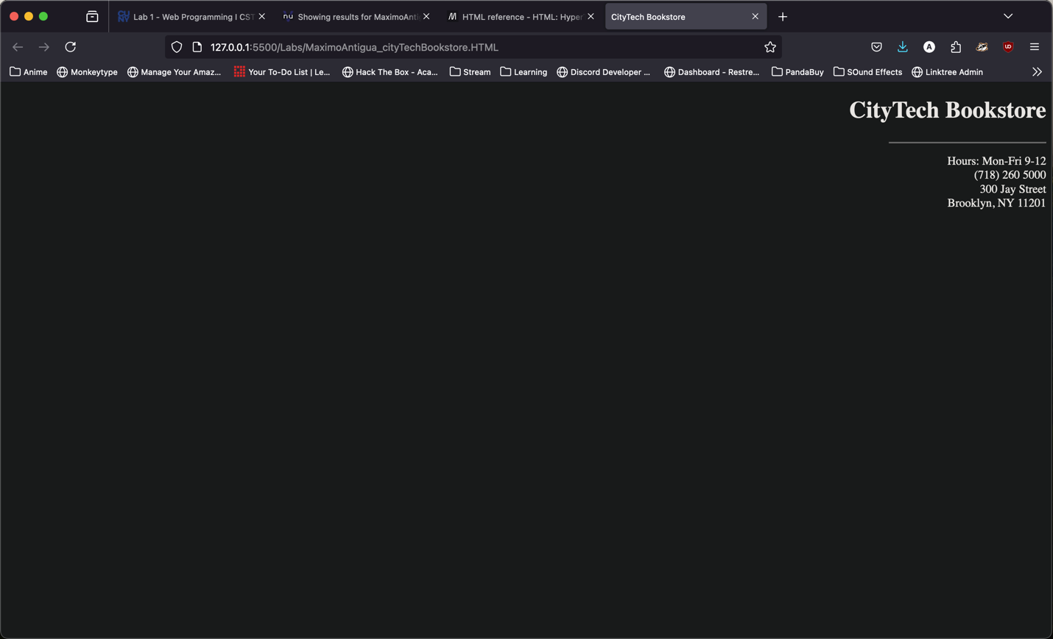

Validate using the W3C Validator. Correct any error

Add a screenshot of the validated file

